4.4)

a. mean: 171.1; median: 170.3

b. sd: 9.4; IQR: 177.8 - 163.8 = 14

c. 180cm: Z=(180 - 171.1)/9.4 = 0.945

155cm: Z=(155 - 171.1)/9.4 = -1.71

Both are within 2 SD's of the mean, so neither value is considered unusual.

d. No, I would expect the mean and standard deviation of the new sample to be slightly different that this one. They vary from sample to sample.

e. We use the SE, which is 9.4/sqrt(507) = 0.4175

4.14)

a. False: Inference is made on the poplation parameter, not the point estimate.

b. False: CLT. Since n = 436, the sample mean will be nearly normal.

c. False: The confidence interval is not about a sample mean

d. True

e. True

f. False: In order to decrease the margin of error to a third of what it is, you would need to use a sample that is 9 times larger.

g. True: 89.11-80.31=8.8/2 = 4.4

4.24)

a. The conditions for inference are satisfied:

- the sample observations are independent: simple random sample and less than 10% of pop sampled.

- n > 30: n=36

- the population distribution is not strongly skewed

b. H0: µ = 32

Ha: µ ˂ 32

Z = (30.69 - 32)/ (4.31/sqrt(36)) = -1.82; p-value: pnorm(-1.82, 0 , 1) = 0.0343

c. 0.0343 ˂ 0.10 therefore we have sufficient evidence to reject the null hypothesis. This suggests that

there is sufficient evidence that the true average age at which gifted children first count to 10 is less

than 32 months.

d. 90% confidence interval:

30.69 ± 1.65 (SE = 4.31/sqrt(36))

(29.504, 31.875)

e. Yes, the results agree. 32 falls outside of the 90% CI.

4.26)

a. H0: µ = 100

Ha: µ ≠ 100

Z = (118.2 - 100)/ (6.5/sqrt(36)) = 16.8; p-value: 2\*(1- pnorm(16.8, 0 , 1)) = 0

0 < 0.10 therefore we have sufficient evidence to reject the null hypothesis

b. 90% confidence interval:

118.2 ± 1.65 (SE = 6.5/sqrt(36))

(116.41, 119.99)

c. Yes, the results agree. 100 falls outside of the 90% CI.

4.34)

The sampling distribution of the mean is the distribution of means of random samples taken from

that distribution.

As sample size increases, the shape becomes more normal, the center becomes closer to the population mean, and the spread decreases.

4.40) N(µ=9000, sd=1000)

a. Z = (10500-9000)/1000 = 1.5

1-pnorm(1.5, 0, 1) = 0.0668

b. Nearly normal with distribution N(µ=9000, sd=1000/sqrt(15) = 258.2 )

c. Z = (10500-9000)/ 258.2 = 5.81

1-pnorm(5.81, 0, 1) ≈ 0

d. I couldn’t figure out how to increase the Y axis

s <- seq(5000,14000, length=500)

plot(s, dnorm(s,9000, 1000), type="l")

lines(s, dnorm(s,9000, 258.2), col="red")

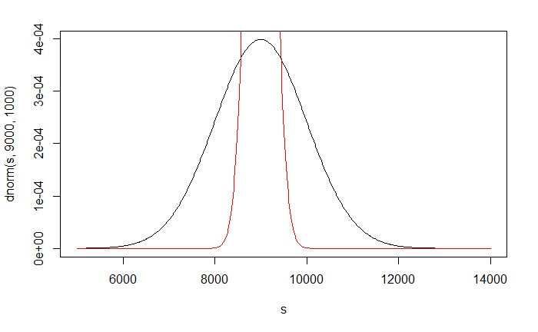

e. We could not estimate a. without a nearly normal population distribution. We also could not estimate c. since the sample size is not sufficient to yield a nearly normal sampling distribution if the population is not nearly normal.

4.48)

The p-value will decrease. The SE would decrease, which in turn would increase the Z score. Having a

larger Z score would decrease the p-value.